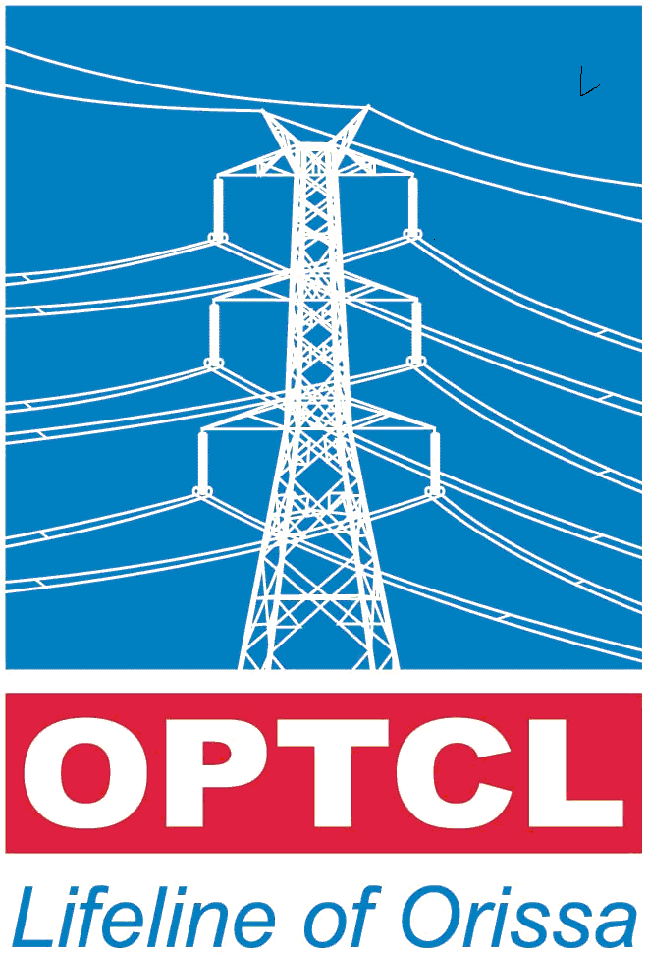ORISSA POWER TRANSMISSION CORPORATION LTD

REGD. OFFICE, JANAPATH, BHUBANESWAR –751022, ORISSA.

EMC- 21 / 07/ dt. 09.02.12
SHORT QUATATION CALL NOTICE- 07
Sealed quotations are invited from reputed electrical Contractor for Internal electrification of elevator headroom at OPTCL building, OPTCL, BBSR duly super scribed on the cover as : “ Quotation for Internal electrification of elevator headroom at OPTCL building, OPTCL, BBSR ”. The quotations will be received upto 1.00 PM on dt. .02.12 & shall be opened on same day at 4.00PM. The firm are requested to submit the PAN & TIN along with the tender.
Serial No | Description of Items | UNIT | Quantity | Unit Rate in ` | Total Rate in `
1 | Recessed wiring to light point/ fan point/ exhaust fan point/ call bell point with 1.5sqmm FR PVC insulated single core multistrand copper conductor of ISI marked with 20mm dia non-metallic PVC flixible conduit with 5Amp, 250V piano type switch ISI marked and ceiling rose ISI marked mounted on MS box having front bakelite cover of suitable size, MS box with 1.5sqmm FRPVC insulated single core multistrand copper conductor as earth wire including all accessories and connection as per direction of Engineer-in-charge. (Make: Finlex/L&T/ Anchor/ Havels/ KDK/) Group- B | Point | 9
2 | Recessed wiring 5/6amp socket outlet with 2X 1.5sqmm FR PVC insulted single core multistrand copper conductor of ISI marked with 20mm dia non-metallic PVC flixible conduit with 5Amp, 250V piano type switch ISI marked and ceiling rose ISI marked mounted on MS box and earthing point with 1X1.5sqmm FR PVC insulated single core multistrand copper conductor for loop earthing etc. as required. (Make: Finlex/L&T/ Anchor/ Havels) | Point | 5
2 | Supplying & fixing of Metal box of 180mmX100mm x 60mm deep with BK cover including providing & fixing 6pin 5/6 & 15/16 amps socket outlet and 15/16 Amp piano type switch, connection painting etc as required. | Point | 2
4 | Wiring for circuit / submain wiring alongwith earth wire with the following sizes of FR PVC insulted single core multistrand copper conductor of ISI marked confoming to IS-694/1990 in 20mm dia non-metallic heavy duty flexible conduit 1.6mm in surface/ recessed PVC conduit as required. (Make: Finolex/L&T/ Anchor/ Havels/ KDK)
I | 2x1.5sq.mm + 1X1.5sqmm | Per Mtr. | 60
ii | 2x4sq.mm + 1X1.5sqmm | Per Mtr. | 40
Serial No | Description of Items | UNIT | Quantity | Unit Rate in ` | Total Rate in `
5 | Supply & fixing of 200Amp, 25KA 4pole MCCB in a cubical panel, making connection etc(One in the headroom & other is at GF Panel room). as required. | each | 2
6 | Supply & fixing of single pole MCB with Sheet steel enclosure, distribution board, on surface/ recess,complete with tinned copper busbar, netural busbar, earthbar, detachable gland plate, interconnection, phoshate and powder painted including earthing etc. with 4Nos. of 10Amp, SPMCB in a cubical panel, making connection etc. (4Nos. 10A MCB-) | each | 1
7 | Supply & fixing of 300mm Exhaust Fan with louvers(Bajaj/ Usha/ Vguard make) as required. | each | 1
8 | Supply & fixing of 1X11W light fittings with lamp etc.(Make: Philips/ Bajaj/CG) as required. | each | 4
9 | Supply & fixing of 1X36W light fittings with lamp etc (Make: Philips/ Bajaj/CG). as required. | each | 4
10 | Supplying & laying of 25mmX 6mm GI earth Strip ISI marked at wall surface of elevator duct including slodering etc. as required. | Mtr. | 60
 | Total

(Rupees ……………………………………………………………………………….)

The price should be inclusive of all taxes & duties including transporting charges. The materials should be guaranteed for trouble free service for a period of 12months from the date of supply. 100% payment will be made after completion of work and verification thereof by SDO (Elect)OPTCL, Bhubaneswar. The offer shall remain valid for a period of 90days from the date of tender opening.

OPTCL reserves the right to reject any or all the tenders without assigning any reason thereof.

SR. GENERAL MANAGER [C.P.C.]

CC to CGM(IT), OPTCL for kind inf. & n/a. He is requested to host the tender in the OPTCL website for wide publication.
AGM(F), CPC
DDO(Headqrs), OPTCL
All Notice board of OPTCL & Gridco , Bhubaneswar for wide publication.

